
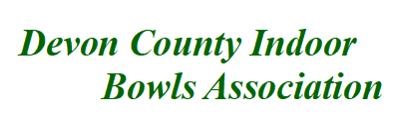
COUNTY COMPETITION ENTRY FORM – 2025/26
CLUB………………………………………………

County Singles Entry Fee £5.00 per player, (Competition will comprise of 21 shots, no time limit)
Name | Tel No | email

One name only per entre for the Un-Badge pairs, CountyPairs, County Triples.

County Unbadge Pairs Entry Fee £5.00 per player, (Competition will comprise of 18 ends 3 hours 30 minutes)
Name: (Skip, name and details only) | Tel No | email
County Pairs Entry Fee £5.00 per player (Competition will comprise of 18 ends 3 hours 30 minutes)
Name: (Skip, name and details only) | Tel No | email
County Triples Entry Fee £5.00 per player (Competition will comprise of 18 ends 3 hours 30 minutes)
Name: (Skip, name and details only) | Tel No | email

Entry Forms to be sent to: Competition Secretary Chris Beer.
2 Easterley Terrace, Bickington Rd, Barnstaple, Devon, EX31 2HF.
Tel: 01271 549 207 / 07516 864 969: email chrisbeer37@yahoo.com

NB for the purposes of GDPR, contact details entered onto this form permit DCIBA use on their website, for facilitating direct contact between competitors and between DCIBA and competitors.
All information will be removed from our web site on a regular basis.
Bank A/C Details: 00572940. Sort Code 30-95-08
Further Entry Forms are available from DCIBA website www devoncountyindoobowls.co.uk
CLOSING DATE 5/11/2025

