
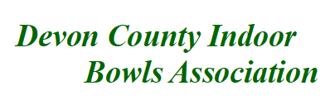

County Competitions season 2025 /2026

County Singles: Entry fee £5.00 per player.
County Triples: Entry fee £5.00 per player.
County Pairs: Entry fee £5.00 per player.

Open to members of Affiliated Clubs.

Prize money will be awarded to the finalist & losing semi-finalist
(Subject to number of entries received)
----------

County Un-badged Pairs: Entry fee £5.00 per player.
Players who have not been awarded their full County badge, prior to the 1st October of the season in which the competition will take place, can still enter this competition.

Open to members of Affiliated Clubs.

Prize money will be awarded to the finalist & losing semi-finalist
(Subject to number of entries received)
----------

Contact your Club Secretary for an entry form, alternatively a form is available from the DCIBA web site (www. Devoncountyindoorbowls.co.uk).

The FINAL will be held on Saturday 4th or Sunday 5th April 2026 at the
County President Club Honiton I.B.C.

County Competition Secretary Chris Beer.
2 Easterley Terrace, Bickington Road, Barnstaple, Devon, EX31 2HF.

Tel No: 01271 549 207 / 07516 864 969.
Email: chrisbeer37@yahoo.com

CLOSING DATE FOR ENTRIES 5/11/2025

